Article to deploy web application to dynamically route viewer requests to any origin usin Lambda@Edge.

<https://aws.amazon.com/blogs/networking-and-content-delivery/dynamically-route-viewer-requests-to-any-origin-using-lambdaedge/>

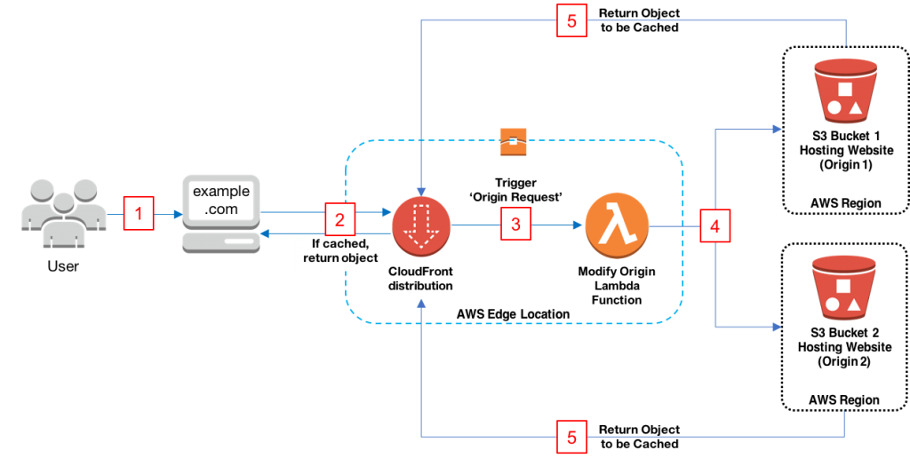

<https://bestofreactjs.com/repo/danielcondemarin-serverless-nextjs-plugin-react-nextjs-extensions>

